Chapter 11, Problem 17.

Calculate the value of Z_{L} in the circuit of Fig. 11.50 in order for Z_{L} to receive maximum average power. What is the maximum average power received by Z_{L}?

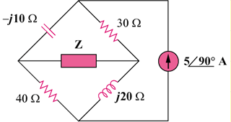
L

Figure 11.50
For Prob. 11.17.

